

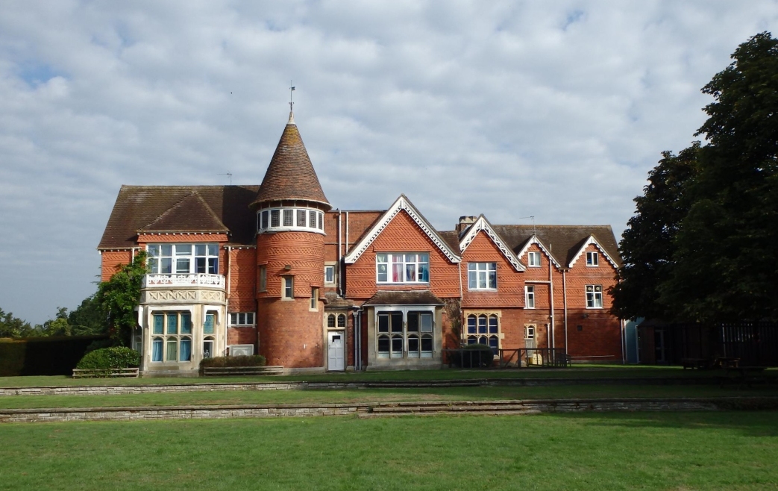

FAMILY AND VISITOR CHARTER
Please note this information is aimed at helping to create a stress-free and happy time when visiting your child.

These guidelines provide expectations on the standards of behaviour, information on health and safety and safeguarding.

Further information can be obtained from the full Family and Visitor Charter document which is available via the school website. If you have any questions about the above information or something that is not covered, please contact the school.

The Loddon School®
Wildmoor Lane
Sherfield-on-Loddon
Hook , Hampshire, RG27 0JD
Tel: +44 (0)1256 884600
This document details the standards of behaviour and mutual respect the school asks all visitors to follow.
The school expects all visitors to:

• Behave reasonably at all times.
• Give attention and due care to their own safety as well as that of the whole school community.
• No dogs are allowed on site without prior permission from the Leadership Team.
• The school is mainly a smoke-free zone. If you wish to smoke, staff can direct you to a smoking shelter at St Michael’s.

When arriving at the school, all visitors must:

• Report to the main School office.
• Wear a visitor badge.
• Switch off your mobile phone and put it in a bag or zipped pocket.
• Please refer to the full charter document for further information on media safety.

You should wear suitable clothing such as:

• Flat comfortable shoes
• Clothing in keeping with the weather but ideally something that still covers your arms and legs.
• No necklaces or anything that can be caught around the neck.

For parents/carers or other family members, if you are bringing in food for your child, please ensure it is:

• In a suitable container
• Clearly labelled with the child’s name
• Clearly labelled if it contains wheat
• Does not contain nuts as we are a nut free site.
• Shows the date it was made, and the date is should be used by.
• All food should be handed in when arriving at the school so it can be put in the fridge straight away.

Please set a good example to the children by:

• Being polite and respectful to others.
• Examples of behaviour that are considered serious and unacceptable are:
• Shouting, swearing, using an aggressive or threatening tone of voice, racist or sexist comments – either in person or on the phone.
• Physical abuse, pushing, hitting, spitting.
• Inappropriate posts on social networking sites.
• Intimidating gestures, standing very close to someone, shaking or holding a fist to another person.

Pre-arranged meetings:
- Please arrive on time and notify the school if you are going to be late.
- If you are late for a meeting, you might be asked to wait until the person you are seeing is available to greet you.
- If you arrive early or late for a meeting, we would ask for your patience.
- Please refer to the full Charter document for further guidance.

For parents/carers or other family members adhoc visits:
- Please report to the main office reception
- For your convenience and comfort, we will attempt to allocate you a space to rest and relax.
- Please arrive before 6.:00pm to avoid disrupting the children’s evening routine.
- You are free to visit any day you wish other than Christmas Day when pick-ups and returns must be arranged in advance.

For Parents/Carers or other family members-home visits:
- The school will provide 6 single journeys home (or 3 return journeys) in a 12-month rolling period.
- Transport by arrangement (and where possible) is available to take your child home and to bring them back to school.
- Transport may be available (as pre-arranged) weekly on a Monday, Tuesday, Thursday and Friday (excluding bank holidays).

